27 January 2021
Knights Road Connection Project update
Dear resident,
The Knights Road Connection project aims to make the journey along Knights Road a safer and more attractive connection regardless of how you choose to get around.
This project is funded 90% by Waka Kotahi NZ Transport Agency’s Innovating Streets for People pilot fund and 10% by Hutt City Council. It uses temporary pathway trials to test out solutions co-designed with the groups of people that use Knights Road the most.
The trial pathway will create better connections between the Lower Hutt CBD, local schools, homes and workplaces, the public transport at Waterloo station and the new Beltway route that supports safe and easy active transport options.
We’re writing to you because the next phase of the project will be starting in mid-February. Installation of the new temporary trial layout between Waterloo Station and Willoughby Street is scheduled for 14-18 February, weather permitting, with the following week as a rain date. We apologise for any inconvenience while the temporary installation is completed.
The five week trial during February and March 2021 is the first opportunity to really test the layout.
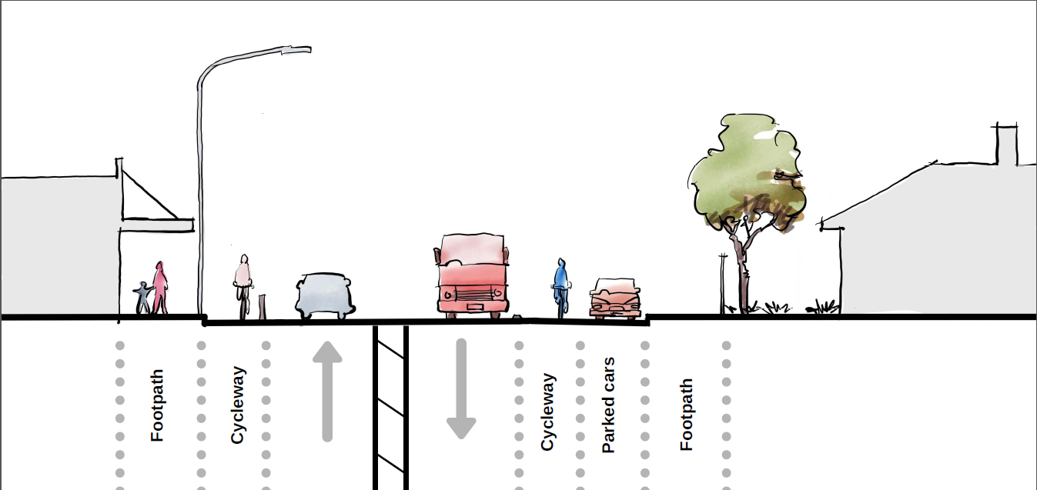
The trial will include:
- Two temporary lanes for cycling, scooting and other active transport modes
- Speed cushions and signage to encourage slower speeds around the Waterloo intersection
- Reduced parking on the south side of Knights Road
- Median strip to allow for turning vehicles into streets and driveways.
The solutions being tested have all been informed by the feedback and engagement with the people that use Knights Road. They include elements that can be safely tested in a temporary way.
During the five week trial, we want to hear what works well and what isn’t working from everyone that uses Knights Road. The feedback from people that use Knights Road alongside ongoing real-time traffic monitoring during the trial will inform what might be trialled on a longer stretch of Knights Road later in 2021. Based on the outcome, the trial will be adapted, extended or removed. You will receive another letter during this time with a form for giving your feedback, and there will be online options as well.
We’ll be promoting all the different ways you can share your feedback through our Facebook page (facebook.com/auahaevolvingspaces), website (auahaevolvingspaces.nz) and on the noticeboards in the Birch Street Park.
If you have any questions you can contact us on auahaevolvingspaces@huttcity.govt.nz or by calling the main Council helpline on 570 6666.
Sincerely,

Aileen Campbell
Knights Road Connection Project Lead

