Q1. How old are you?

Q2. What area do you live in (your suburb)?

______________________________________________
Q3. Which school do you go to?

__________________________________________________

Tick one box for each question | Walk/ Run  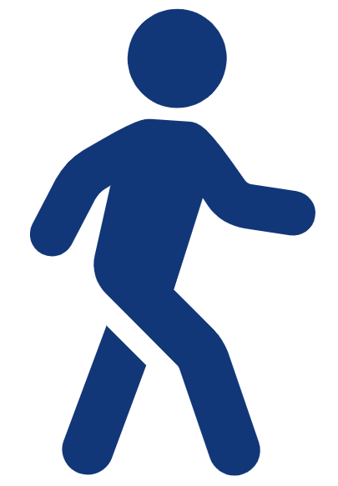 | Bus/  Train  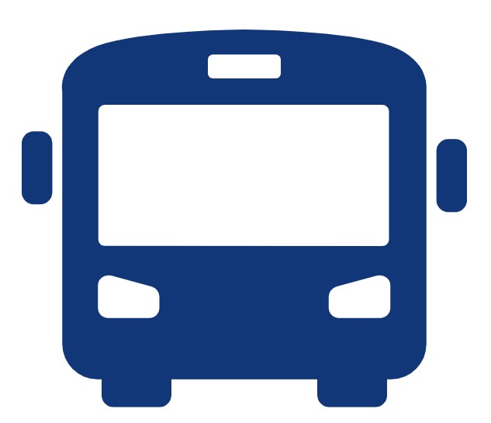 | Bike  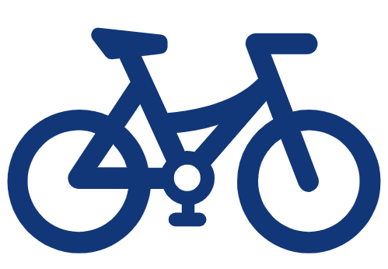 | Scooter  /board   | Other (write in)
Q5. How do you get to school most often?
Q6. How do you get around your neighbourhood?

Q5. Do you have friends who live close to your home?
o Yes o No

Q6. How many days each week do you usually play or hangout with friends who live close to your home?
o 0 o 1 o 2 o 3 o 4 o 5 o 6 o 7

Q7. Who are you allowed to go outside and play with?
(tick all the ones that are true for you)
o On my own
o With my friends
o With my brother and/or sister
o With an adult
o I am not allowed to go outside and play

Q8. What stops you from playing outside more often?
(tick all the ones that are true for you)
o Too much homework
o Too many chores
o Prefer gaming, watching tv or listening to music
o I don’t have any friends in my neighbourhood to play with
o There is nothing to do or nowhere to go and play
o I don’t feel safe

Q9. What would make it easy to play and hangout more often in your neighbourhood?
o Having events to get together with friends and neighbours
o Having more areas to play in
o Having more things to play on or with
o If it was safer to get around, cross roads or, play on the street
o Other (please explain):

_______________________________________________________

Q10. How safe do you feel when you are outside playing in your neighbourhood?
o Not at all safe
o Somewhat safe
o Very safe

Q11. How confident do you feel when you are outside playing in your neighbourhood?
o Not at all confident
o Somewhat confident
o Very confident

Q11. Where do you like to hang out in your neighbourhood?
(you can select more than one place)

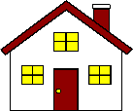 | 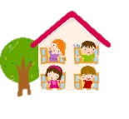 | 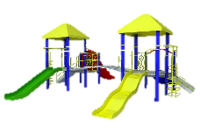 | 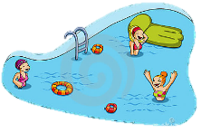
o Home / backyard | o Friend's house | o Playground / park | o Swimming pool
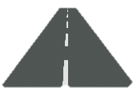 | 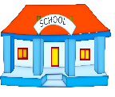 |  | 
o On the street | o At a school | o Sports club | o River / beach
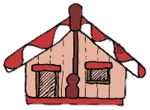 |  |  | 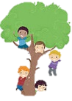
o Marae / church / place of worship | o Shops | o Library | o Natural environment
Other (please explain – you can write or draw)

